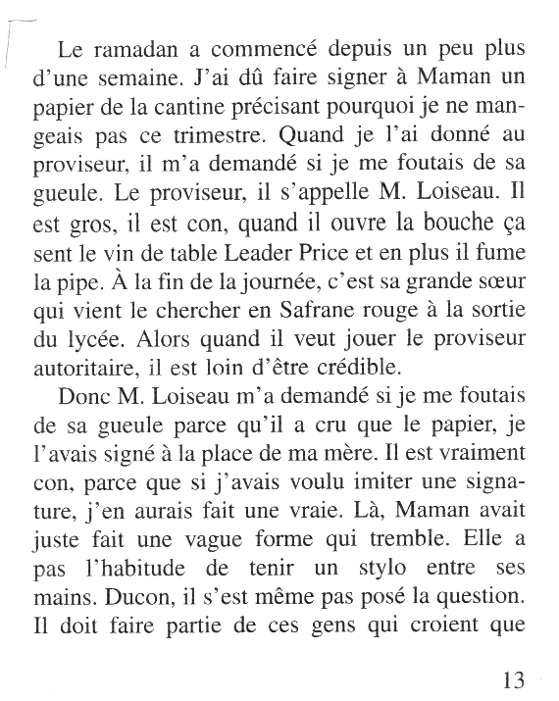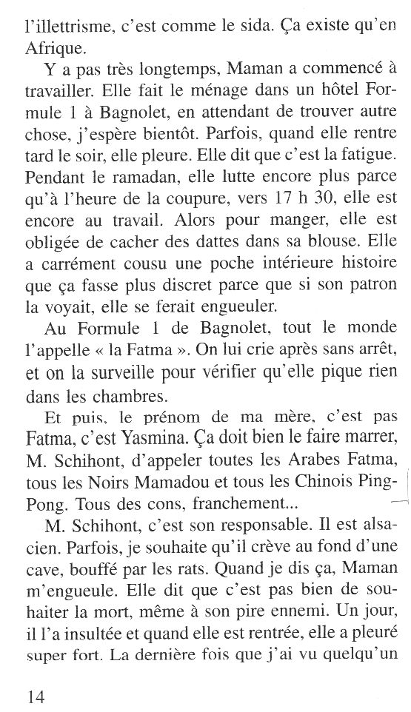

p. 13-14

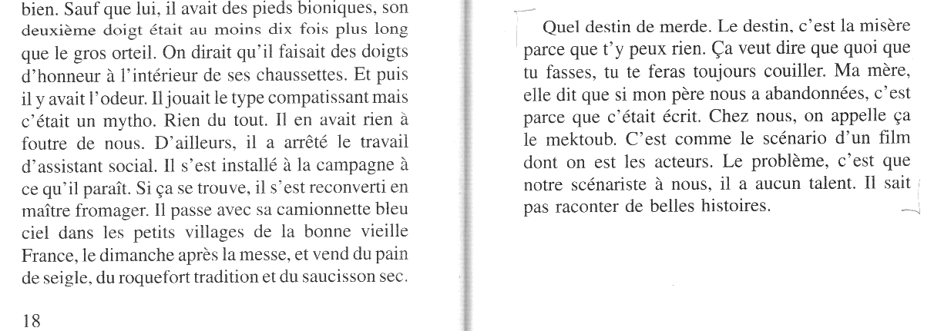

p.19

18

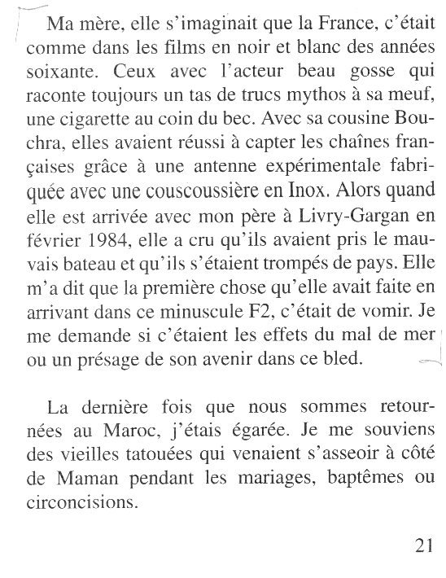

p.21

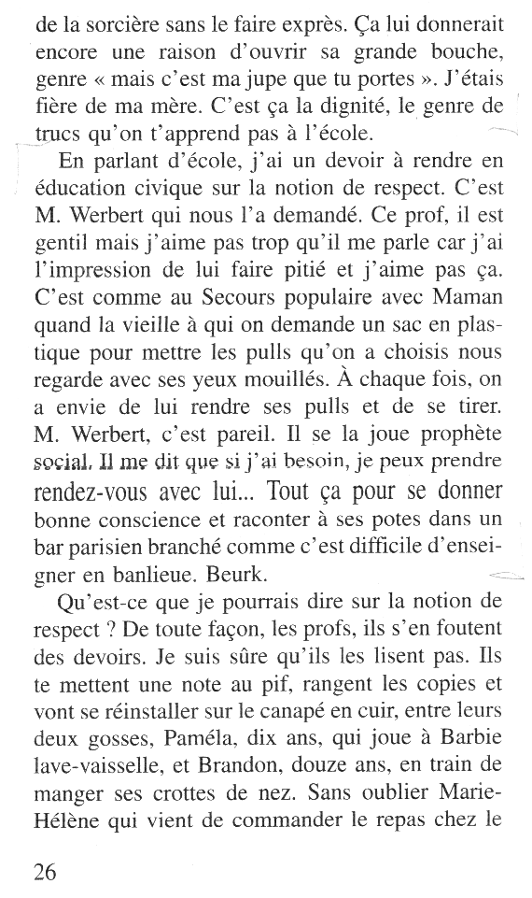

p. 26

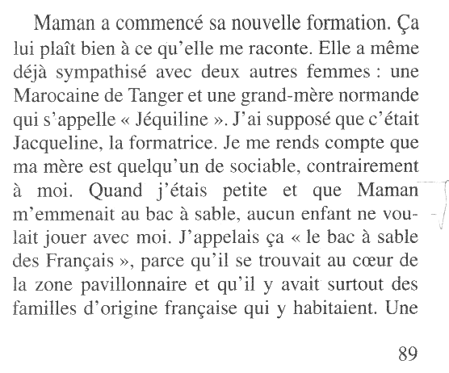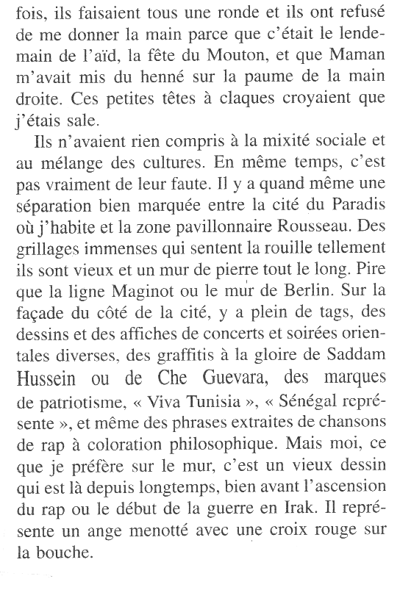

...



...

p. 88-89

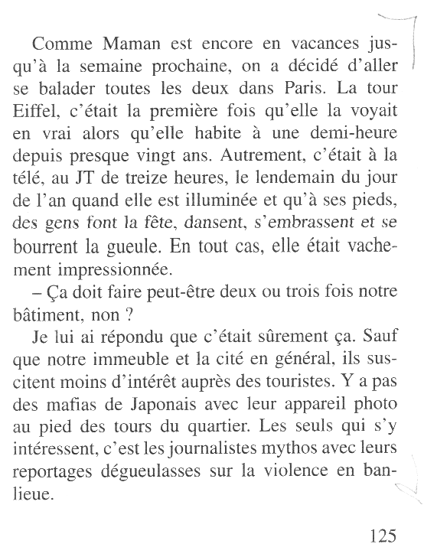

p. 125

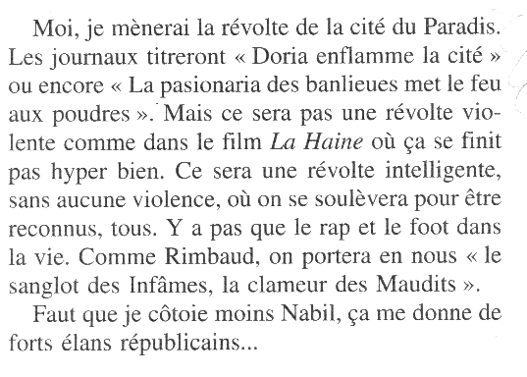

...

p. 189

_ _ _ _ _ _ _ _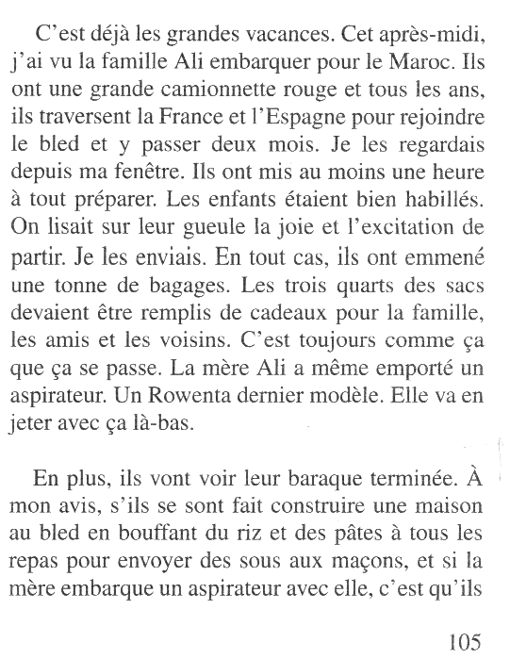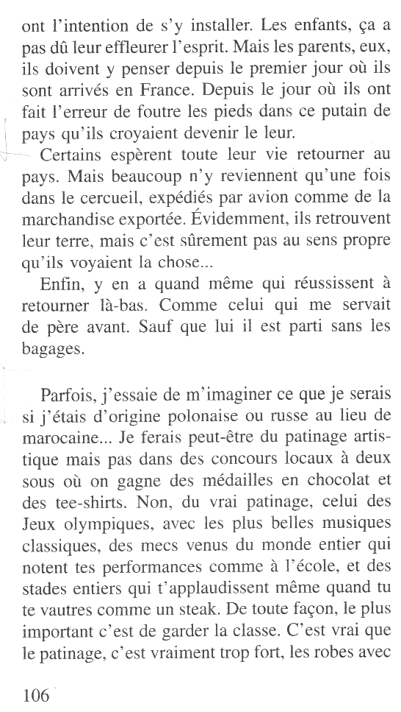 _ _ _ _ _ _ _ _ _ _ _ _ _ _ _ _ _ _ _ _ _ _ _ _ _ _ _ _ _ _ _ _ _ _ _ _ _ _ _ _ _ _ _ _ _ _ _ _ _ _

...

...

...

...





p. 105-106

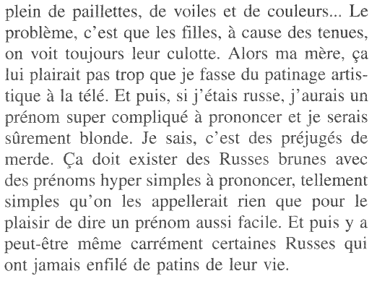

...

p. 106-107

...